EXECUTIVE GAME THEORY CURRICULUM • 12-WEEK MASTER ARCHITECTURE
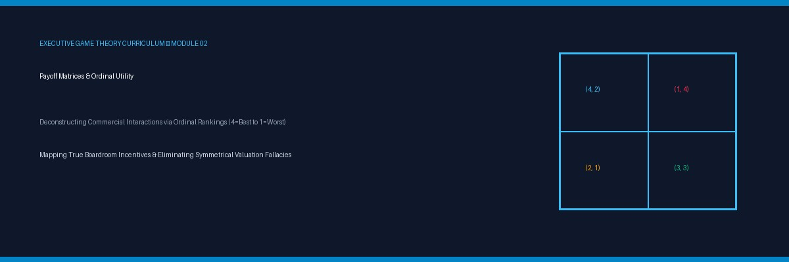

Lesson 02: Constructing Payoff Matrices & Ordinal Utility
Intuitive Reinforcement & Inversion: Projecting Counterparty Survival Priorities & Deconstructing Symmetrical Fallacies
Strategic Focus & Learning Objective: In this topic, we will be learning how to apply Strategic Inversion to Counterparty Payoff Modeling to eliminate the Symmetrical Valuation Blind Spot in corporate standoffs.
The Real-World Operational Problem: Leaders consistently fail to anticipate counterparty attacks because they project their own balance sheet incentives onto their rivals. Assuming that a competitor will respond rationally to maximize corporate cash flow ignores the reality that rivals often optimize for founder survival, debt covenant preservation, or venture equity optics.
How This Topic Solves It: By inverting the payoff matrix from the counterparty's existential viewpoint, executives uncover asymmetric ordinal valuations. An operational move that costs you little may threaten your rival's absolute Rank 1 priority—forcing a massive, seemingly irrational retaliatory strike that blindsides unassisted leadership teams.
■ EXECUTIVE INVERSION ADVISORY
Invert the board: 'What outcome threatens my rival's executive tenure or corporate survival?' If your strategy forces them into their personal Rank 1 disaster, expect desperate, scorched-earth retaliation regardless of financial ROI.

Part I: The 4-Part Prelude Protocol
1. Models in Focus: Payoff Asymmetry Mapping, Non-Monetary Executive Utilities, and Existential Threat Modeling.
2. Lifelike Dilemma: A regional logistics carrier introduces a 15% rate cut on bulk container freight, expecting the debt-burdened incumbent to yield. Instead, the incumbent slashes rates by 35%—well below operating costs—burning millions in cash reserves. The regional carrier is baffled by the incumbent's 'irrational' suicide move.
3. Component Dissection: The regional carrier evaluated only cash profitability. To the incumbent, losing freight volume would immediately breach banking debt covenants, triggering instant loan foreclosure (Rank 1). Cash burn was merely Rank 2; liquidation was Rank 1. The price slash was entirely rational under their true ordinal hierarchy.
4. Lesson Embarkation: We deconstruct how to map asymmetric payoff hierarchies to predict aggressive counter-attacks.

Part II: The 7-Stage Core Pedagogy

Stage 1: Overcoming Symmetrical Projection
Your competitors do not share your cost of capital, your investor base, or your risk tolerances. Inverting the analysis forces you to map their survival constraints.
▼ CHECKPOINT: WHAT YOU MUST KNOW BEFORE MOVING FORWARD
Never assume an adversary thinks like you. What looks like an irrational price war is often a rational defense against a hidden debt covenant or regulatory threat.

Stage 2: The 5-Minute Inversion Framework
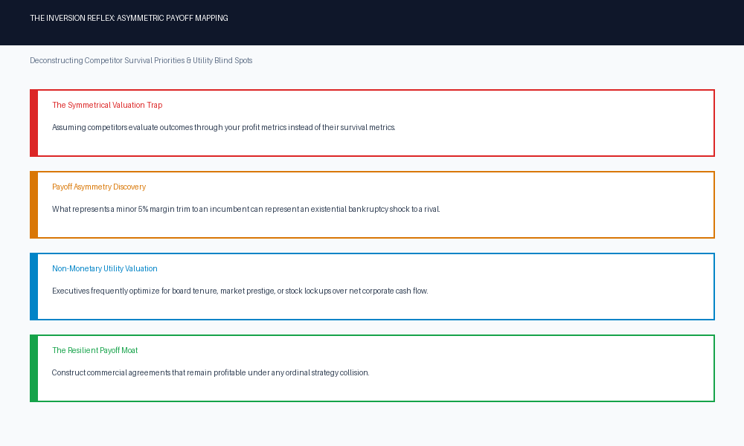
▼ CHECKPOINT: WHAT YOU MUST KNOW BEFORE MOVING FORWARD
If an initiative pushes an adversary into their Rank 1 survival boundary, they will fight with infinite intensity. Build asymmetric moats that avoid triggering their existential panic.

Stage 3 to 7 & Applications
• 3-Layer Deep Dive: (1) Asymmetry Audit Protocol, (2) Solvency vs. Profitability Blind Spot, (3) Regulatory & Investor Governance Boundaries.
• Real-World Cases: (1) Telecom 5G Spectrum Auction overbidding, (2) Enterprise SaaS churn defense via predatory bundling, (3) Contract manufacturing volume guarantees.
• Diagnostic Quiz: Identifying covenant breach triggers in corporate bidding wars.

Topic 02 Companion Games & Obsidian Vault
• Playable Games: Matrix Gridlock & Factory Capacity War on GitHub Pages (https://firedancerx.github.io/Game-Theory/).
• Obsidian Triplets: [[Payoff Asymmetry]] --[governs]--> [[Retaliation Intensity]] | [[Survival Ranks]] --[override]--> [[Profit Optimization]]

